TASK 4: MATHEMATICS ASSESSMENT COMMENTARY
Respond to the prompts below (no more than 8 single-spaced pages, including prompts) by typing your responses within the brackets following each prompt. Do not delete or alter the prompts. Commentary pages exceeding the maximum will not be scored. Attach the assessment you used to evaluate student performance (no more than 5 additional pages) to the end of this file. If you submit feedback as a video or audio clip and your comments to focus students cannot be clearly heard, attach transcriptions of your comments (no more than 2 additional pages) to the end of this file. These pages do not count toward your page total.
1. Analyzing Student Learning—Whole Class
a. Identify the specific learning objectives measured by the formative assessment you chose for analysis.
[The specific learning objectives include:
- Students will be able to collect, sort, and organize data; then ask and answer questions about the number of data points.
- Students will be able to ask and answer varied word problem types about a data set with three categories.]
b. Provide a graphic (chart or table) or narrative that summarizes student learning for the whole class. Be sure to summarize student learning for all evaluation criteria submitted in Mathematics Assessment Task 4, Part D.
[
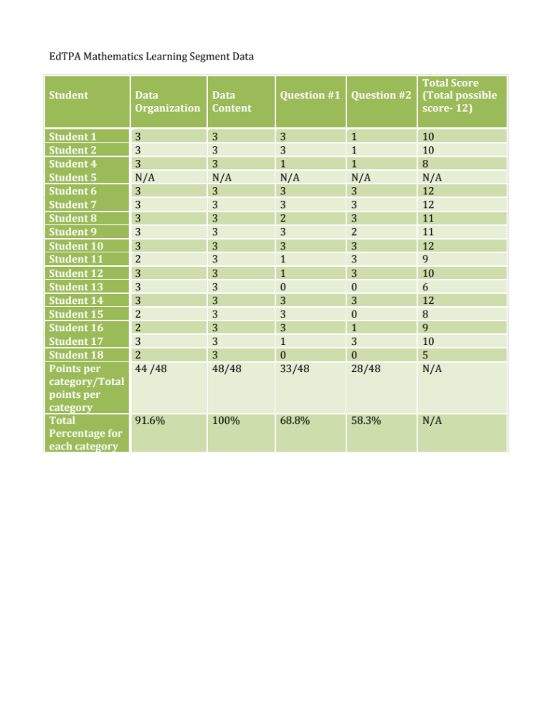

]

c. Using examples from the summary chart, discuss the patterns of learning across the whole class relative to
- conceptual understanding
- procedural fluency
- mathematical reasoning/problem-solving skills
[According to the summary chart, there was a 91.6% success rate for students being able to organize the given data into the table with their squares being arranged without any gaps or overlaps. The students have demonstrated their knowledge of this rule numerous times in application problems, problem sets, and other exit tickets throughout the duration of this learning segment. This success rate proved that a majority of the students exhibited conceptual understanding for data organization, since they were able to transfer their knowledge of this organizational rule into a new data set. They related the rule of no gaps or overlaps from previous practice as they completed this assessment, thus displaying their knowledge of being able to identify and apply principles or rules related to data organization. The next column in the chart shows that there was a 100% success rate for students being able to correctly transfer the data they collected into the table. They were provided with three different zoo animals varying in numbers that they had to place into a data table. This success rate proved that all of the students exhibited conceptual understanding for data content, since they were given a data set that they had never seen before. Organizing zoo animals was new to them, but they were able to connect the idea that each animal is equivalent to one square, and therefore, if there are seven giraffes, then the data table will contain seven squares next to the section labeled “giraffe.” This success rate also demonstrates procedural fluency, since all of the students were able to accurately and efficiently count each animal, and then place the data they collected into the table. Question 1 and Question 2 both showed areas where students struggled with conceptual understanding and problem solving skills. There was only a 68.8% success rate for students being able to comprehend the idea that when they see the word “total” in a word problem or question, it means “altogether,” thus asking them to add. These two questions also asked students to provide a number sentence to show that they were not simply counting the animals, but instead understood how to solve these problems in a mathematical sense. They were unable to relate addition to the key word “total” and subtraction to the key word “fewer.” Therefore, they either did not write the number sentence with the correct sign or did not write a number sentence at all. Question 3 certainly displayed the most confusion with only a 58.3% success rate. They struggled conceptually because they did not understand the comparison being asked. I also believe that the conceptual understanding was low since the students are more familiar with the term “less” than “fewer,” thus causing difficulty in drawing a connection to signs and problem- solving strategies.]
2. Analyzing Student Learning—3 Focus Students
From your analysis of whole class student learning, identify one area where students struggled mathematically. Select 3 student work samples that represent the struggles in this area. These students will be your focus students for this task. At least one of the focus students must have specific learning needs, for example, a student with an IEP (Individualized Education Program) or 504 plan, an English language learner, a struggling reader, an underperforming student or a student with gaps in academic knowledge, and/or a gifted student needing greater support or challenge.
a. In what form did you submit the work samples for the 3 focus students? (Delete choices that do not apply.)
- Written work samples in text files
b. Analyze the 3 students’ work samples and describe the students’ struggle(s) as they relate to the underlying mathematical understanding and/or concept. Cite specific evidence from the work samples in relation to mathematical errors, confusions, and partial understandings.
What do the students’ errors tell you about their mathematical understanding? For example, if a student error occurs in a subtraction problem, then the underlying mathematical understanding may include regrouping, meaning of subtraction, and/or subtraction as the inverse of addition. The related mathematical understanding becomes the basis for the targeted learning objective/goal for the students.
[I chose Question 2 as the area where students struggled mathematically, since there was only a 58.3% success rate in answering this question correctly. This question stated: Write a number sentence to show how many fewer students like elephants than like giraffes. I choose three student samples that displayed the struggles most often found when attempting to answer this specific question. Student 1 answered the question by simply writing “4.” This student most likely did not relate the word “fewer” with subtraction, and therefore did not even attempt to write a number sentence. However, it was obvious that the student did not want to leave the answer blank, so she wrote “4.” I believe she wrote this answer since she did see the word elephants in the word problem. However, since she did not understand what the word problem was asking, so she simply ignored the word “giraffes,” and primary focused on elephants. She came up with 4 as her answer since there were 4 elephants in the data set. Student 2 is extremely gifted and often needs a challenge. I knew she would follow the directions and try her best to answer the question correctly. She knew she needed a number sentence, but again did not relate the word “fewer” with subtraction, and therefore used addition in her number sentence. She did see was supposed to use the data she collected for both elephants and giraffes, so she included the number of giraffes (4) and elephants (7) into her number sentence. Her answer was 11, which would have been correct if the question was asking how many students liked both elephants and giraffes. She knew the basics for solving the problem and demonstrated some problem solving skills and conceptual understanding, but she did not include the proper sign. I am assuming she did not understand that “less” is synonymous with “fewer.” Student 3 greatly struggled with this question. As I circulated the room while the students completed this exit ticket, I noticed that he had completely given up and put his head down on his desk. He did not even attempt to solve the problem. Other students resorted to this as well, since they were ultimately confused. He is very intelligent, so I knew he would be able to understand upon re-engagement, so I choose this student as a focus student to see if he was able to understand the question after the follow-up lesson was implemented.]
c. If a video or audio work sample occurs in a group context (e.g., discussion), provide the name of the clip and clearly describe how the scorer can identify the focus student(s) (e.g., position, physical description) whose work is portrayed.
[Not applicable]
3. Developing Students’ Mathematical Understanding
a. Based on your analysis of the focus students’ work samples, write a targeted learning objective/goal for the students related to the area of struggle.
[Students will be able to answer word problems including the key words “total,” “more,” and “fewer” based upon data that they collect, sort, and organize.]
b. Describe the re-engagement lesson you designed to develop each focus student’s mathematical knowledge in relation to the targeted learning objective/goal. Your description should include
- targeted learning objective/goal from prompt 3a
- state-adopted academic content standards that were the basis of the analysis
- strategies and learning tasks to re-engage students (including what you and the students will be doing)
- representations and other instructional resources/materials used to re-engage students in learning
- assessments for monitoring student learning during the lesson (e.g., pair share, use of individual whiteboards, quick quiz)
[The targeted learning objective for the re-engagement is: Students will be able to answer word problems including the terms “total,” “more,” and “fewer” based upon data that they collect, sort, and organize. I specifically want students to be able to solve word problem that include the word “fewer,” since that was the main area of struggle amongst the majority of the students. However, I also want to teach the students tips and tricks for when the see the other key words, such as “total” and “more,” in word problems relating to data sets since that is apart of the CCSS. The Common Core State Standard that was the basis of the analysis is: CCSS.MATH.CONTENT.1.MD.C.4 Organize, represent, and interpret data with up to three categories; ask and answer questions about the total number of data points, how many in each category, and how many more or less are in one category than in another.
I am going to begin the lesson by having students use their personal white boards to solve an application problem. I will place a piece of paper (Lesson Materials 1.1) under the document camera that contains 7 packets of Sour Patch Kids, 5 mini Snickers bars, and 2 individual Reese’s Peanut Butter Cups. I will say: I was cleaning my house and came across my bag of Halloween candy that I thought I lost. In my bag I found 7 packets of Sour Patch Kids, 5 mini Snickers bars, and 2 Reese’s Peanut Butter Cups. If I were to create a table with this data I collected from my Halloween bag, what would the table look like? How many pieces of candy do I have in total? Write a number sentence to show how you solved for the total pieces of candy. Once this exercise is complete, I will randomly select a student to place their white board under the document camera, and have him/her explain how they organized their data, and how they solved for the total.
After the application problem, I will have the students join me at the carpet for the lesson, after writing the objective on the white board. I will display the new anchor chart titled Word Problem Tips and Tricks (Lesson Materials 1.2). This anchor chart will contain 3 questions: 1. How many TOTAL candies?; 2. How many MORE sour patch kids than snickers?; 3. How many FEWER Reese’s cups than snickers? These questions relate the application, so the data will be the same, thus allowing the students to make a connection. I will put pictures of each of the candies under the questions, and randomly select students to tell me how to solve each problem and why it should be solved that way. I will then add the correct signs into the picture number sentence and then write whether we used addition or subtract. This will help the students visualize the word problems and help them understand that when they see the word “”total” they add, when they see “more” they subtract, and when they see “fewer” they also subtract. At this point, I will connect the fact that “fewer” and “less” are essentially the same thing when asked in a word problem. I will then hide the chart, and ask students questions such as: If I had 5 pencils and 2 erasers, how many fewer erasers do I have than pencils. I will first have the students pair-share about whether they use addition or subtraction, and then I will have them pair-share again in order to come up with the number sentence and solve. I will also review that when subtracting, the bigger number is always placed first in the number sentence, but when adding the order does not matter.
After the lesson, students will return to their seats where they will be given a worksheet titled M&M Data Collection (Lesson Materials 1.3) for the lesson’s main activity. The worksheet will state: Directions- Open your bag of M&M’s and place them in the first box. Then sort them into different color groups and draw what you see in the second box. There will be two empty boxes in this section of the paper. Below that section, the worksheet will state: Directions- Use squares with no gaps or overlaps to organize the M&M data you collected. There will be a table with the colors red, green, blue, orange, yellow, and brown listed on the left side, and the right side will be blank so the students can record their data. Each student will receive a plastic bag containing the 1 red, 3 green, 4 blue, 5 orange, 2 yellow, and 1 brown M&M. I will have organized it this way in order to ask questions where everyone would have the same answer.
Upon sorting and organizing their data in the table, they will take out their personal white boards again to answer questions. I will remind about the anchor chart and ask what signs are used when the key words “total,” “more,” and “fewer” are in the word problem being asked. I will then ask questions, such as: Write a number sentence and solve to show how many MORE orange M&M’s you have than green M&Ms; Write a number sentence and solve to show how many MORE yellow M&M’s you have than red M&Ms; Write a number sentence and solve to show how many FEWER yellow M&M’s you have than blue M&M’s; Write a number sentence and solve to show how many FEWER brown M&M’s you have than green M&Ms; Write a number sentence to show how you would solve for the TOTAL amount of M&M’s you have and then solve. The students will write their answers on their white boards and display them after each question, so I can survey which students are understanding and which students are struggling.
The students will then be allowed to eat their candy as they complete the exit ticket (Lesson Materials 1.4), which has a similar set-up to the initial formative assessment. For this assessment, they will be counting cupcakes, ice cream, and cookies and organizing that data into a table by drawing squares with no gaps or overlaps. They will then be asked 3 questions: 1. Write a number sentence to show how many TOTAL students were asked about their favorite dessert item. 2. Write a number sentence to show how many MORE students voted for cupcakes than cookies. 3. Write a number sentence to show how many FEWER students like ice cream than cupcakes.
Informal formative assessments within this lesson include pair-share, personal white boards (application problem and main activity), and teacher circulation. Formal assessments include the M&M Data Collection worksheet and the exit ticket. A summative assessment will be given following this module where the students will be asked to sort and organize data, as well as answer word problems that are similar to the ones asked in this activity.]

Before responding to prompt 4, you will teach your re-engagement lesson. This lesson may be taught with the 3 focus students one-on-one, in a small group, or with the whole class.
4. Analyzing Teaching
Cite evidence from the 3 focus students’ work samples from the re-engagement lesson to support your response to prompt 4b.
- In what form did you submit the 3 students’ work samples from the re-engagement lesson?
- Written work samples in text files
b. Analyze the effectiveness of the strategies you used during the re-engagement lesson to develop students’ mathematical understanding in the identified area of struggle.
Consider the change in students’ mathematical understanding or misconception(s) in relation to the identified area of struggle when describing the effectiveness of the re-engagement lesson.
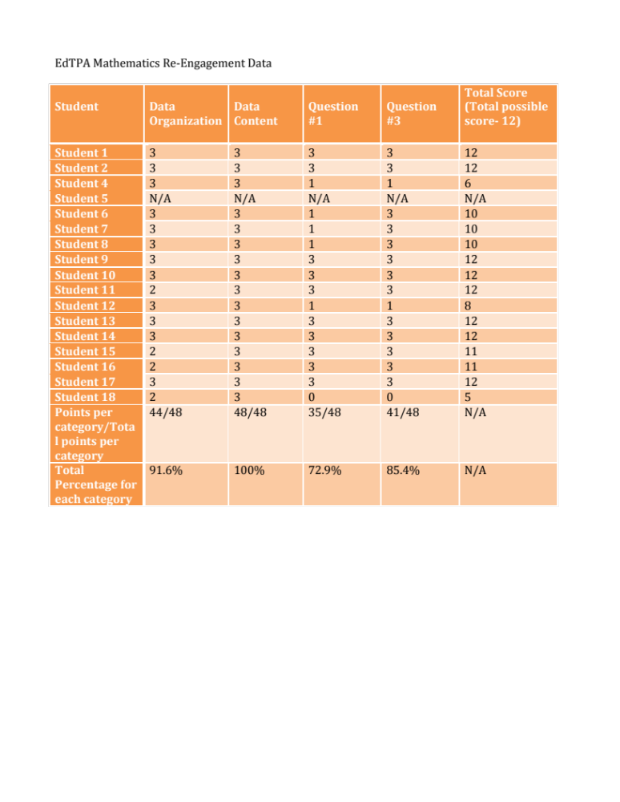
[

The table displayed above is the data I collected from the exit ticket I created for the re-engagement lesson. It is clear that there was an increase in class-wide comprehension for Question #1, which coincides with Question #1 from the initial formative assessment, and Question #3, which coincides with Question #2 from the initial formative assessment. There was a 4.1% increase of student comprehension when the word “total” is in a world problem. There was a 27.1% increase in student comprehension for when the word “fewer” is in a word problem. I am extremely impressed that there was that big of an increase for the question containing the word “fewer.” This increase in understanding can be viewed in the re-engagement exit ticket completed by all three focus students. Each focus student managed to answer every question correctly. For Question #3, which is the word problem containing the key word “fewer,” the students each wrote the correct number sentence and the correct answer. This was a big improvement from the first formative assessment. Student 3, the student who had ultimately given up during the initial formative assessment, was actually the first one to complete this exit ticket, and he did not once doubt his mathematical abilities as he solved the problems. The data table and the work from all three focus students definitely proves that my teaching strategies and instructional materials were effective in developing the student’s mathematical understanding when it comes to solving word problems based upon information from a data set. I think the most effective aspect of the lesson was the anchor chart. This displayed what signs, plus or minus, a number sentence should contain when being asked for the total, more than, or fewer than. This certainly helped the students better understand the concept. I think the other extremely effective aspect of the lesson was the M&M data activity. The students were very engaged in this data collection and they had fun with what they were doing. They work with manipulatives quite often in the Eureka Math Program, but the candy was a real treat, and definitely motivated them to grasp the information that I was teaching them even more than usual. Overall, I am pleased with the outcome, and I believe that each aspect of the re-engagement lesson played a role in the increase in student understanding.]
c. If a video or audio work sample occurs in a group context (e.g., discussion), provide the name of the clip and clearly describe how the scorer can identify the focus student(s) (e.g., position, physical description) whose work is portrayed.
[Not applicable]
Lesson Materials:
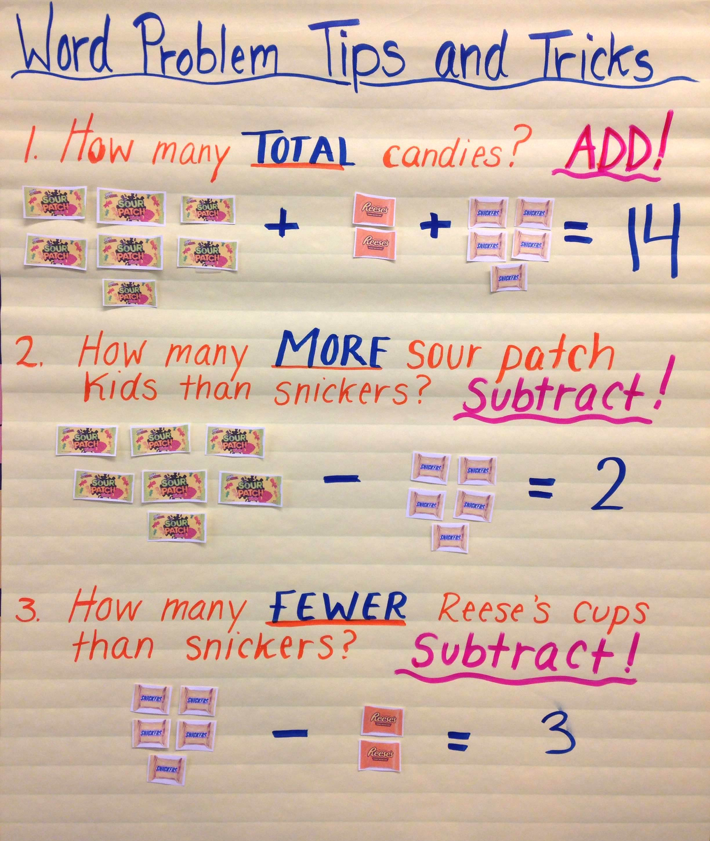
1.1 1.2
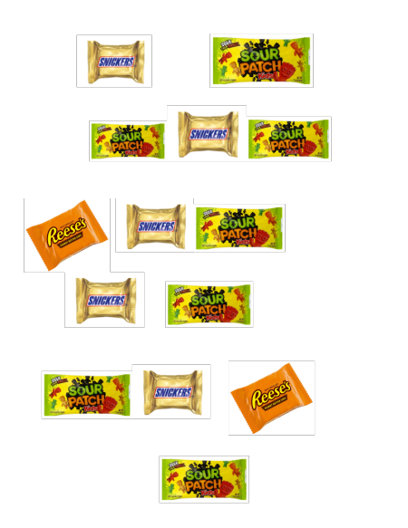

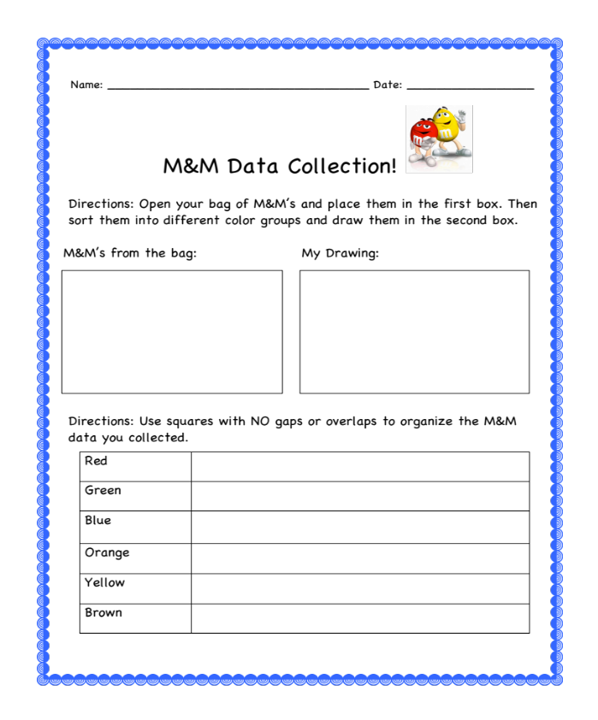
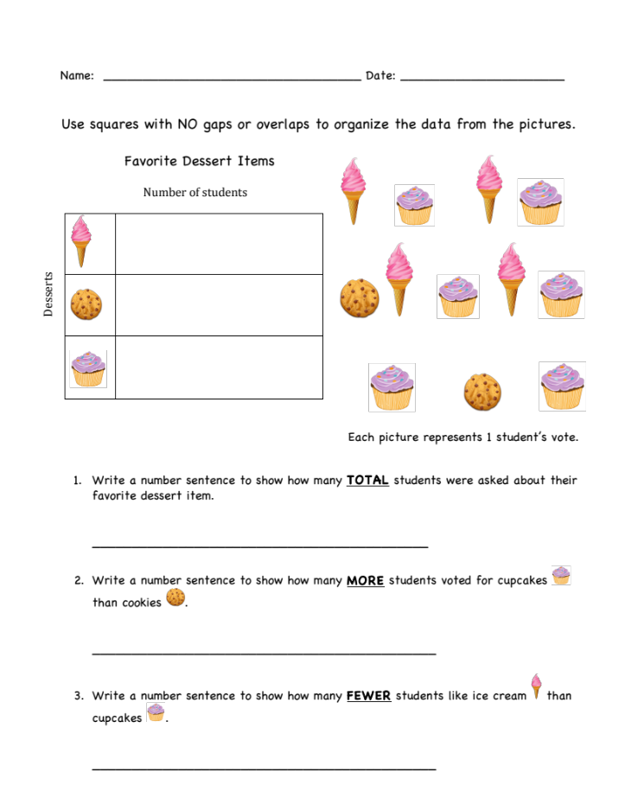
1.3
1.4

